Saddle Brook Mayor’s Youth Group
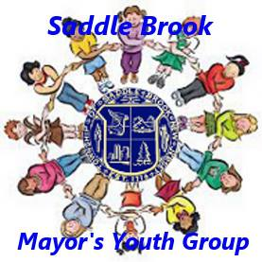
Meeting Agenda 5/21/2022

Call Meeting to Order

Pledge of Allegiance

Introduction of New Members, if any

Old Business

Memorial Day Parade
- Will be held on Sunday, May 29th at 1:30pm
- We will meet by the Korean War monuments at 1pm (corner of Fairlawn Parkway and Skillman Terrace). There will be a memorial service there at that time for anyone who wants to attend.

Fishing Derby
- Saturday, June 18th from 9am-12pm at the Saddle Brook Park
- We need 3 or 4 volunteers for the event. We hope other people will participate.

Township Picnic
- Saturday, July 2nd from 12pm to 4pm at the Saddle Brook Park
- Volunteers needed to bring food and drinks to seniors in attendance.

Fireworks
- Saturday, July 2nd at 9:15pm at the Saddle Brook Park (same day as picnic)
- No volunteers will be needed, but you are all welcome to come and enjoy the show!

New Business

Adjourn Meeting

