Saddle Brook Mayor’s Youth Group
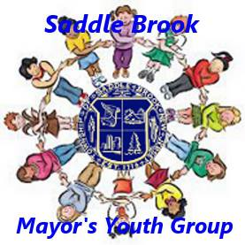
Meeting Agenda 10/23/2021

Call Meeting to Order

Pledge of Allegiance

Old Business

Upcoming Youth Group Events
- Senior Halloween Party – Tuesday, October 26th from 6-9pm at VFW
  - Address: 44 Market Street
  - We will help serve beverages to seniors in attendance
  - Feel free to wear your costumes!
- Halloween Decorating Contest
  - Contest will end on Wednesday, October 27th
  - Members will be visiting each house and scoring them between October 27th and October 30th.
  - Submit choices for winners to cgenuario@saddlebrooknj.gov or saddlebrookmyg@gmail.com
  - Winners will be announced on Saturday, October 30th along with photos on Facebook page.
- Trunk or Treat
  - When: Saturday, October 30th from 12-2pm (rain date is October 31st)
  - Where: Parking lot of new municipal complex, 55 Mayhill Street
  - Members are asked to arrive at 11:30am.

New Business
Adjourn Meeting

